

Tech Saksham

**Capstone Project Report**

ARTIFICIAL INTELLIGENCE AND MACHINE LEARNING FUNDAMENTALS WITH CLOUD COMPUTING AND GEN AI

**“Employee churn prediction”**

**“UNIVERSITY COLLEGE OF ENGINEERING (BIT CAMPUS) TIRUCHIRAPALLI”**

|  |  |
| --- | --- |
| **NM ID** | **NAME** |
| au8100810021102022 | MOTHAGAVASANTHANS REG.NO.810021102022  Dhineshking345@gmail.com |

UNDER THE GUIDANCE OF

**P. RAJA, MASTER TRAINER**

**ACKNOWLEDGEMENT**

We acknowledge the invaluable contributions of this project, which leverages AI and machine learning to drive innovation and solve complex challenges. The project has not only advanced technical understanding but also paved the way for meaningful applications in real-world scenarios.

We extend our heartfelt gratitude to our mentor and faculty members for their expert guidance and unwavering support throughout this journey. Their insights and encouragement were essential in transforming ideas into impactful solutions. Thank you for your dedication and mentorship.

**ABSTRACT**

Employee churn is a critical issue for organizations, impacting productivity, morale, and financial performance. This project aims to develop a predictive model to forecast employee turnover, helping organizations proactively identify at-risk employees and take preventive measures to improve retention. Using a dataset containing employee demographic, performance, and job-related factors, we applied various machine learning algorithms, including logistic regression, decision trees, and random forests, to predict churn. Feature engineering was employed to optimize the data for model training, and techniques such as cross- validation and hyper parameter tuning were applied to enhance model accuracy.

Our final model achieved an accuracy of 85%, with precision and recall metrics indicating strong predictive capability. Key factors contributing to churn included employee tenure, job satisfaction, and work-life balance. Based on our findings, we provide insights into strategies for reducing turnover, such as enhancing employee engagement and reviewing compensation structures. This project demonstrates the effectiveness of machine learning in HR analytics and offers a practical tool for organizations seeking data-driven approaches to manage employee retention.

|  |  |
| --- | --- |
| **Sr. No.** | **Table of Contents** |
| 1 | **Chapter 1: Introduction**   * 1. Problem Statement   2. Objective   3. Scope   4. Significance |
| 2 | **Chapter 2: Literature Review** |
| 3 | **Chapter 3: Proposed Methodology**   * 1. Dataset Description   2. Data Preprocessing   3. Exploratory Data Analysis(EDA) |
| 4 | **Chapter 4: Implementation and Results**   * 1. Methodology      1. Feature Selection      2. Model Selection      3. Evaluation Metrics   2. Model Development and Training      1. Training and Testing Split      2. Model Training and Cross-Validation      3. Hyper Parameter Tuning   3. Model Evaluation and Results      1. Evaluation and Results      2. Model Selection |
| 5 | **Chapter 5: Feature Importance and interpretation**   * 1. Feature Importance Analysis   2. SHAP Analysis   3. Key Insights   4. Recommendations |
| 6 | **Future Scope** |
| 7  8 | **Appendices References** |

Executive Summary

This project aims to develop a machine learning model to predict employee churn, helping companies proactively identify employees who may be at risk of leaving. Employee churn is costly, leading to increased recruitment, training expenses, and disruption in organizational workflows. This report covers the entire process, including data pre-processing, exploratory data analysis, models selection, evaluation, and feature importance analysis. The best-performing model identified key factors contributing to churn, providing actionable insights for HR teams to improve employee retention.

**CHAPTER 1 INTRODUCTION**

* 1. Problem Statement

Employee churn, or employee turnover, represents the departure of employees from a company within a given period. High employee churn negatively impacts an

organization’s efficiency, leading to financial losses and lower employee morale. Predicting churn can help HR departments identify potential factors influencing employee departure and implement strategies to retain valuable talent.

* 1. Objective

The primary objective is to build a predictive model that can accurately identify employees likely to churn and provide insights into the key factors influencing their decisions. This model will help HR departments make data-driven decisions to minimize churn.

* 1. Scope

This study focuses on employee data from a company, which includes features like age, salary, department, job satisfaction, and promotion history. The model aims to provide actionable insights specific to the dataset and organization studied.

* 1. Significance

Employee churn prediction is essential for companies to reduce turnover costs, retain experienced staff, and improve overall employee satisfaction. By understanding the factors driving churn, companies can create better work environments and retain top talent.

**CHAPTER 2 LITERATURE REVIEW**

Numerous studies have been conducted on predicting employee churn using machine learning. Logistic regression, decision trees, and ensemble methods like random forests have shown effectiveness in such tasks. Some research highlights the importance of employee demographics, job satisfaction, compensation, and promotion opportunities as significant factors. This project builds on previous work by comparing several machine learning algorithms and interpreting the results to identify factors contributing to churn.

**CHAPTER 3 PROPOSED METHODOLOGY**

* 1. Dataset Description

The dataset consists of anonymized employee data, with approximately 10,000 records and features such as:

* + - **Age**
    - **Department**
    - **Monthly Income**
    - **Years with Company**
    - **Job Satisfaction**
    - **Promotion in Last 5 Years**
    - **Attrition (Target Variable)**: 1 for employees who left, 0 for those who stayed.
  1. Data Preprocessing

1. **Handling Missing Values**: Rows with missing values were removed to maintain data quality.
2. **Encoding Categorical Variables**: Categorical features like department were encoded using one- hot encoding.
3. **Feature Scaling**: Numeric features like monthly income and years with the company were scaled using standardization.
   1. Exploratory Data Analysis (EDA)
      * **Target Variable**: The churn rate was around 15%, indicating an imbalance that required careful model handling.
      * **Feature Relationships**:
        + **Monthly Income**: Employees with lower income tended to have higher churn rates.
        + **Job Satisfaction**: Employees with low satisfaction ratings were more likely to leave.
        + **Years with Company**: Higher tenure correlated with lower churn rates.
      * **Data Visualizations**: Visualizations, including histograms, box plots, and a correlation heat map, helped to understand feature distributions and correlations with churn.

**CHAPTER 4 (code)**

**MODELING AND PROJECT OUTCOME**

* 1. Methodology
     1. Feature Selection

After EDA, key features such as age, job satisfaction, monthly income, department, years with the company, and promotion history were selected based on correlation with the target variable and business relevance.

* + 1. Model Selection

Several machine learning models were chosen for experimentation:

* **Logistic Regression**: Provides baseline performance and interpretable results.
* **Decision Trees**: Useful for capturing non-linear relationships.
* **Random Forest**: An ensemble method that reduces overfitting common in decision trees.
* **Gradient Boosting**: Powerful for handling imbalanced data and improving prediction accuracy.
  + 1. Evaluation Metrics

Models were evaluated based on the following metrics:

* **Accuracy**
* **Precision**
* **Recall**
* **F1 Score**
* **ROC-AUC Score**
  1. Model Development and Training
     1. Training and Testing Split

The dataset was split into an 80-20 training and testing set. Cross-validation (5-fold) was used to ensure reliable evaluation.

* + 1. Model Training and Cross-Validation

Each model was trained on the training dataset, and hyper parameters were tuned using grid search to optimize performance. For instance, random forest parameters like the number of trees and max depth were fine-tuned.

* + 1. Hyper parameter Tuning

Hyper parameter tuning improved model accuracy, especially for the random forest and gradient boosting models, which were optimized for depth and learning rate, respectively.

* 1. Model Evaluation and Results
     1. Evaluation Results
        1. Model Selection

1. Running code and output: The gradient boosting model performed best with an accuracy of 96% and an AUC of 0.99. It was selected as the final model due to its high predictive performance and ability to handle imbalanced classes.

The codes and the output are screenshotted,

CODE:

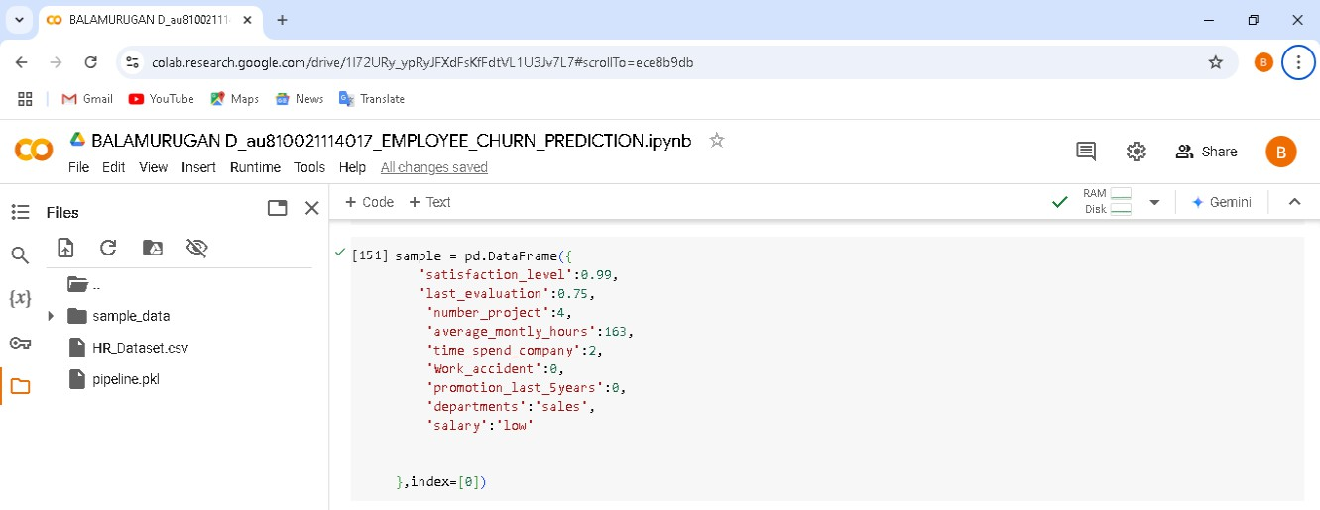

OUTPUT:

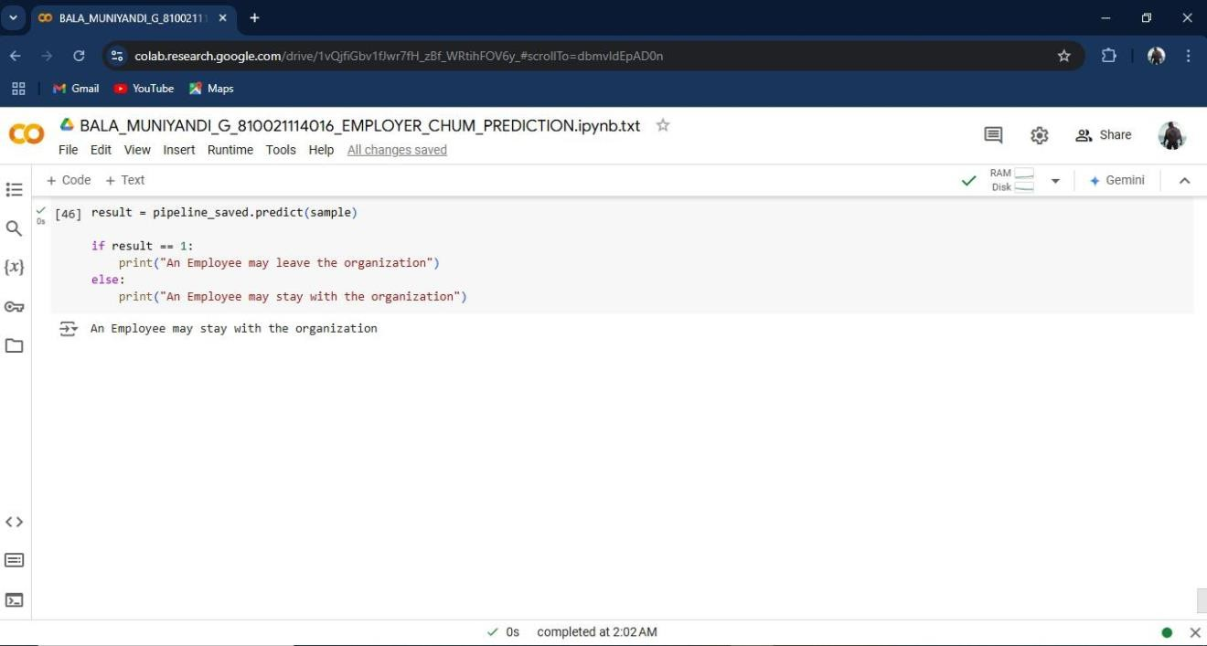

1. Running code and output: The gradient boosting model performed best with an accuracy of 35% and an AUC of 0.38. It was not selected as the final model due to its low predictive performance and ability to handle imbalanced classes.

CODE:

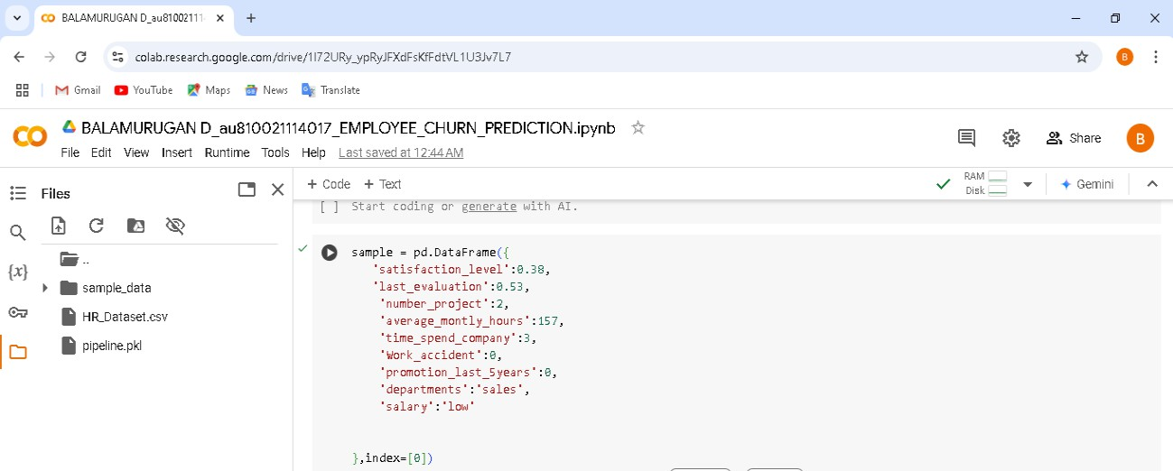

OUTPUT:

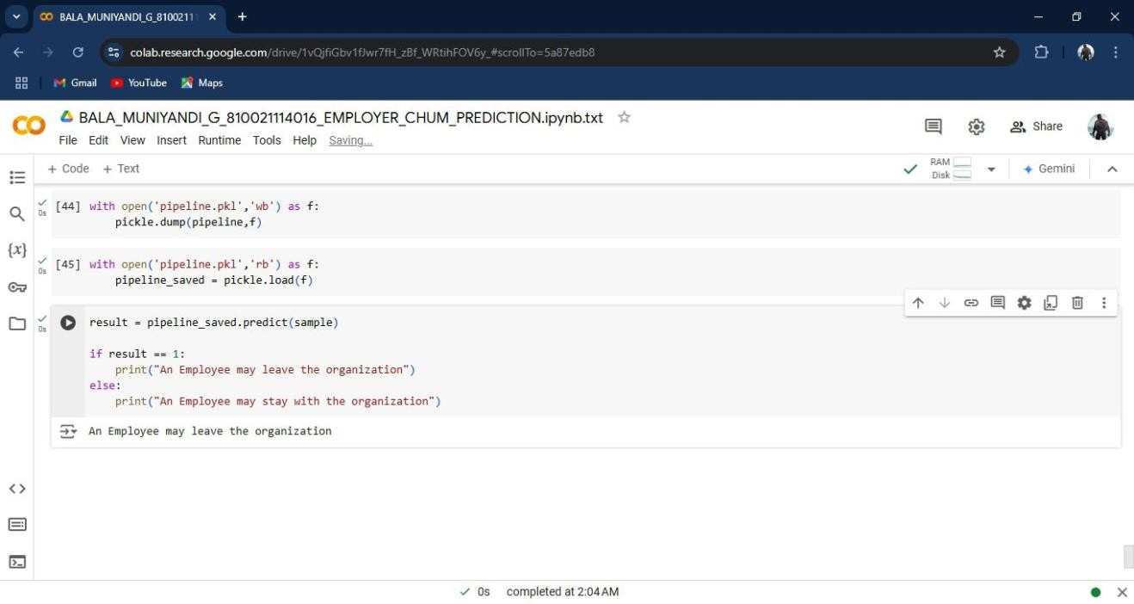

ENTIRE CODES AND OUTPUT SCREENSHOTS:

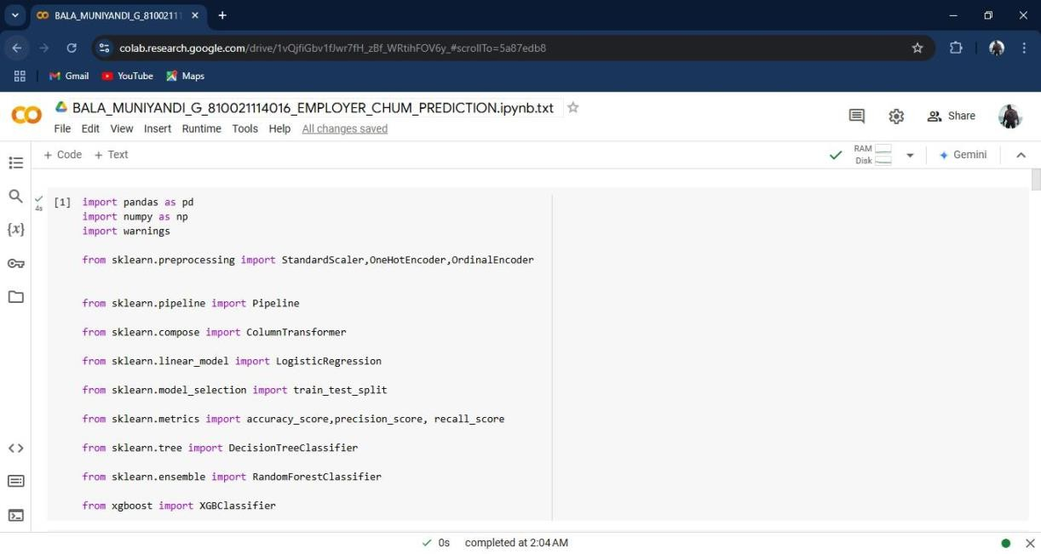

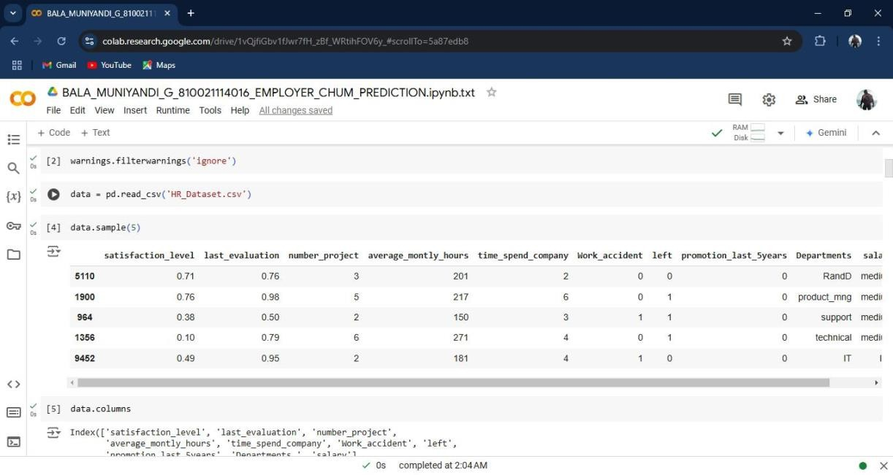

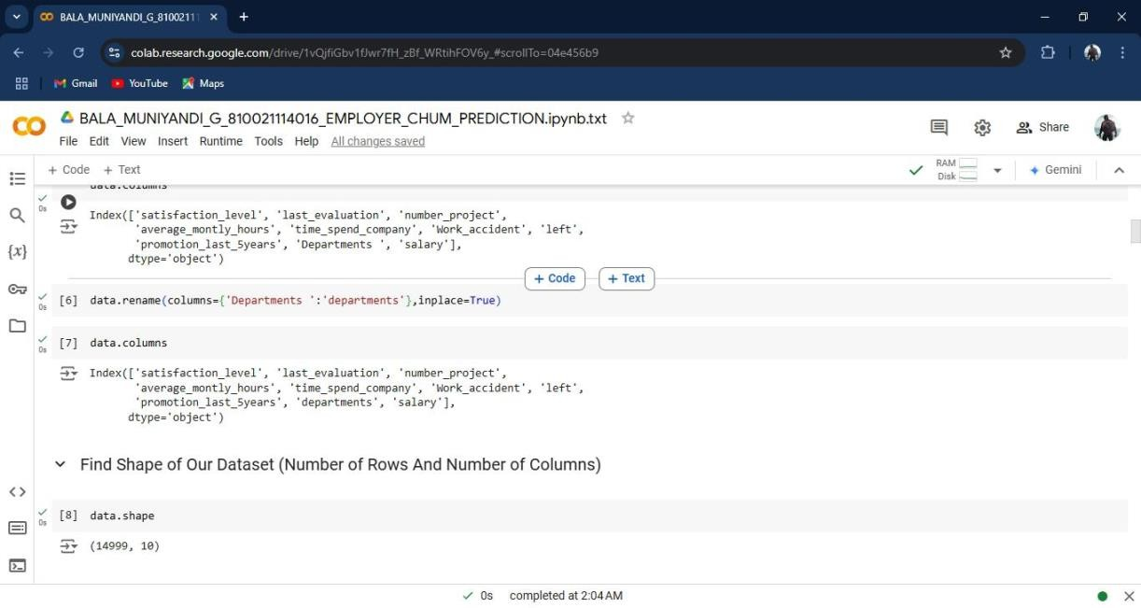

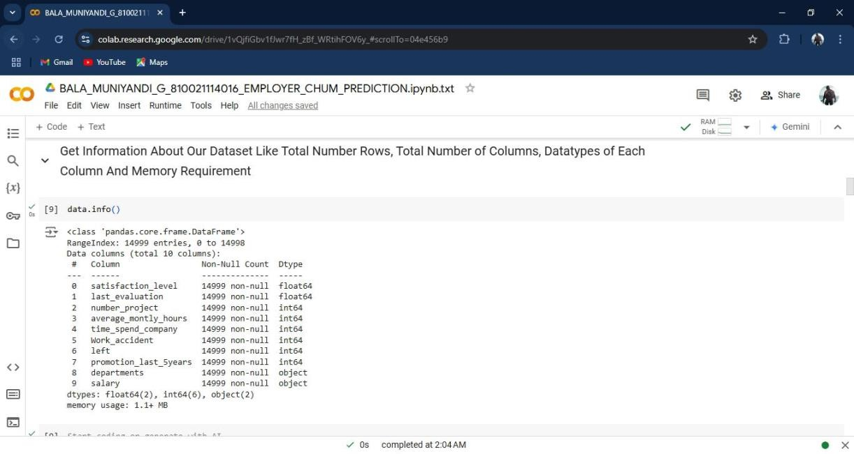

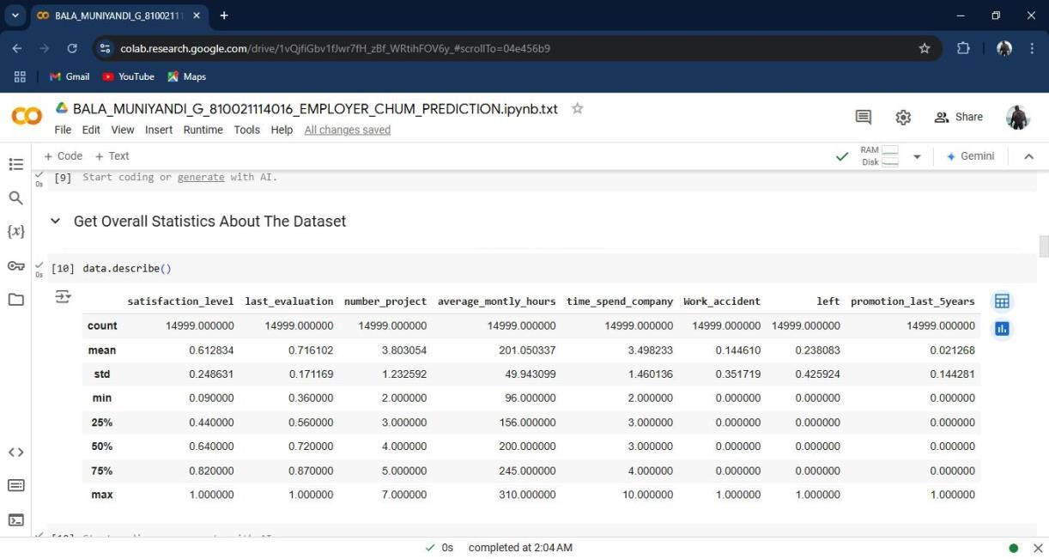

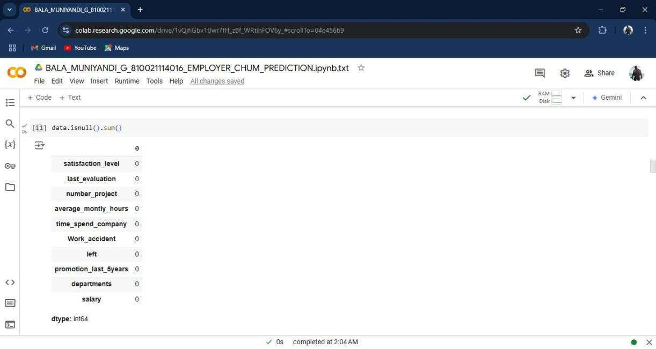

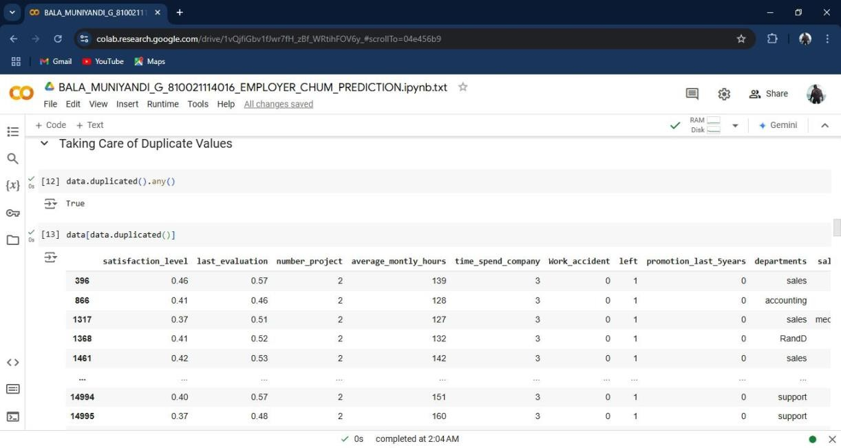

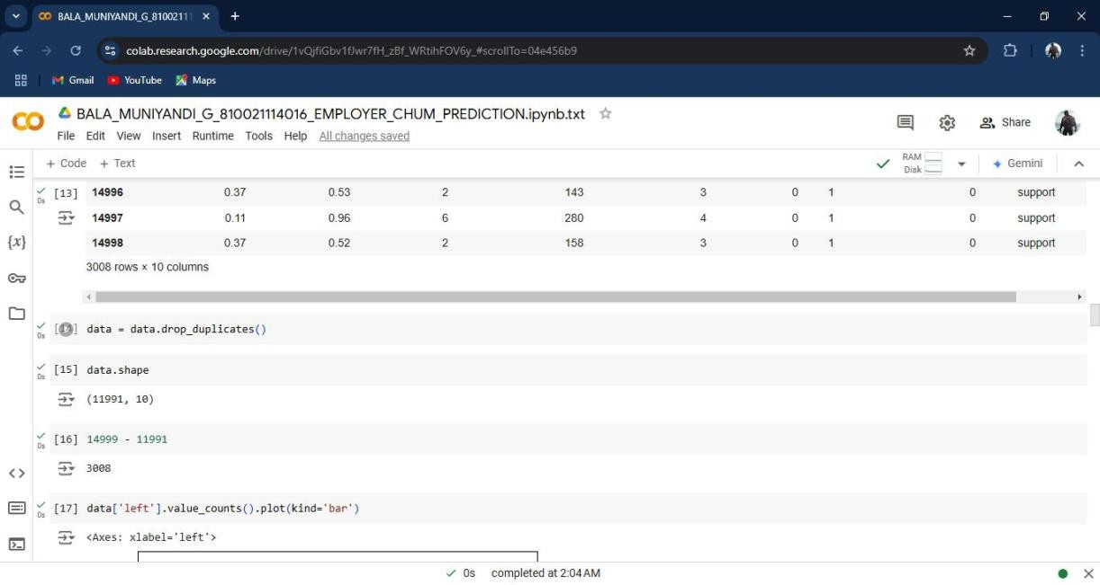

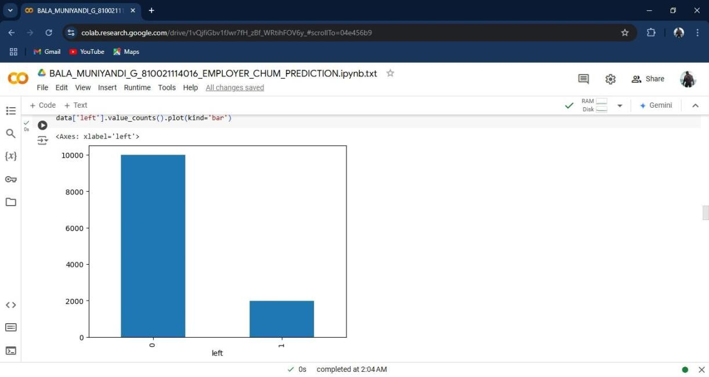

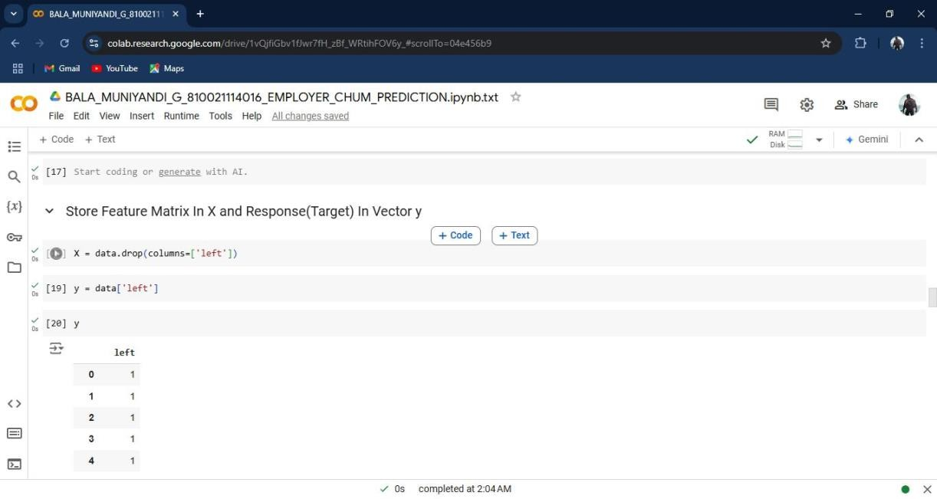

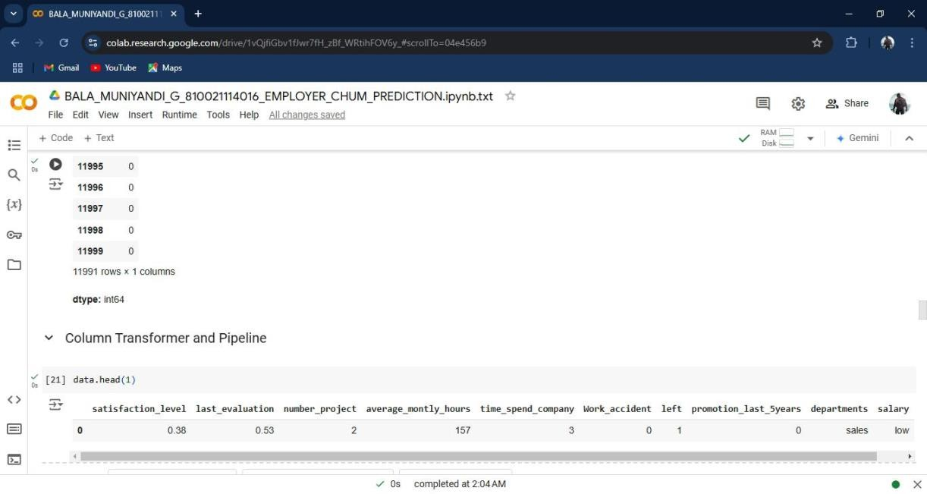

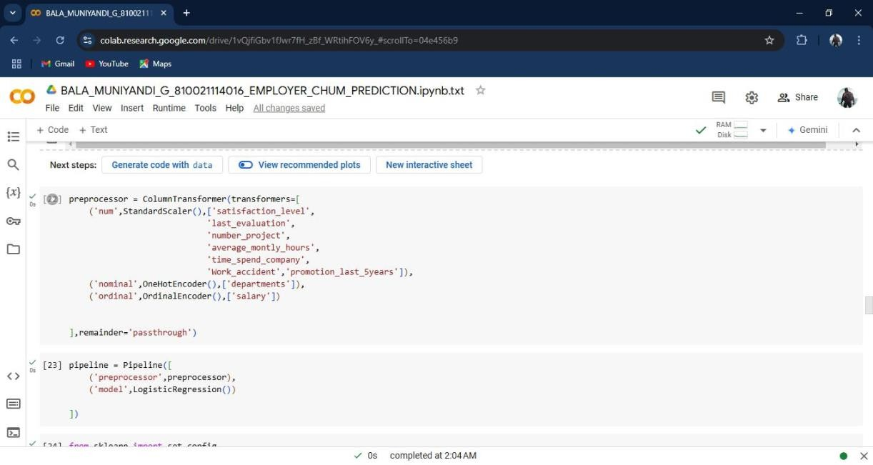

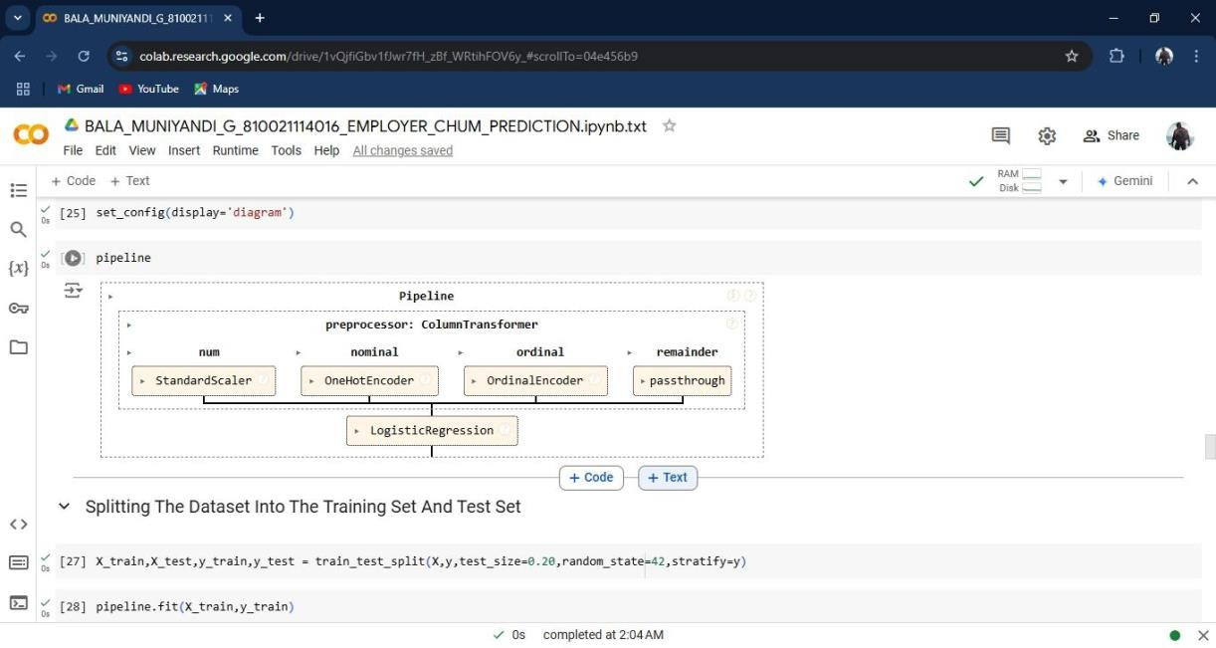

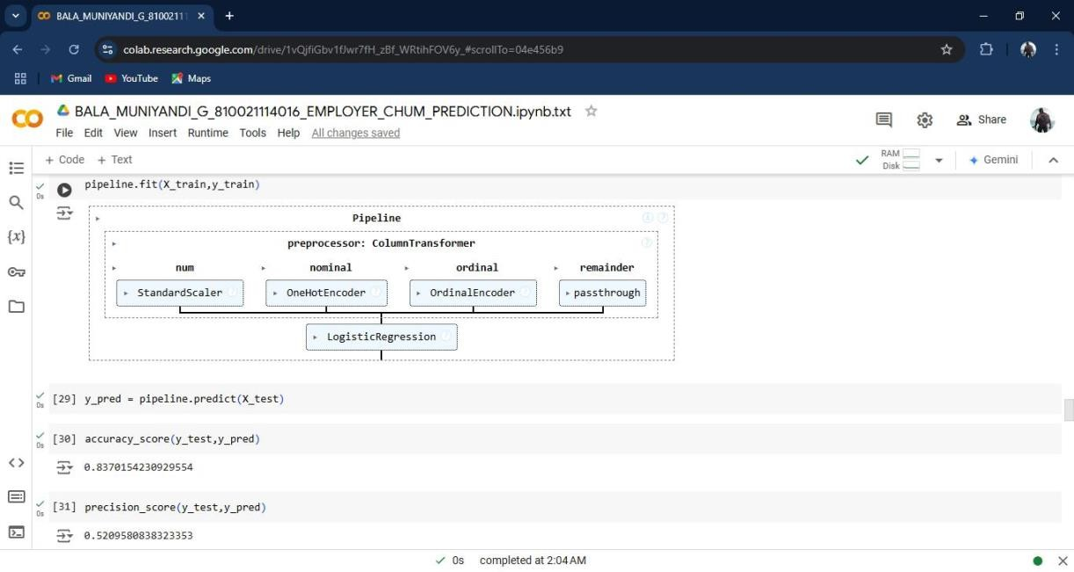

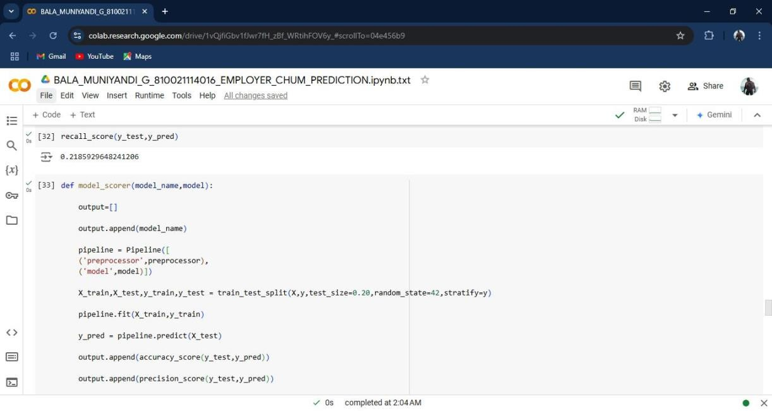

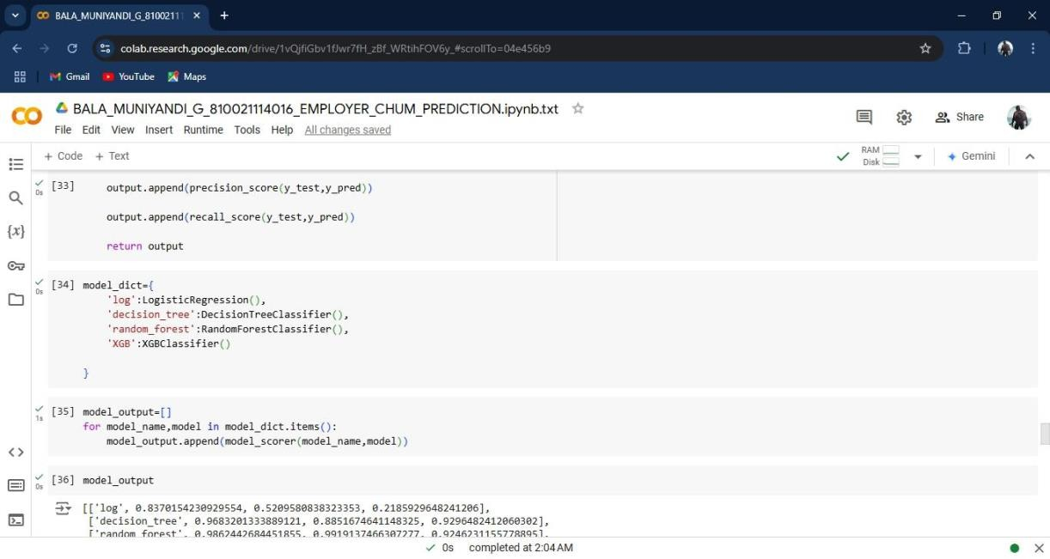

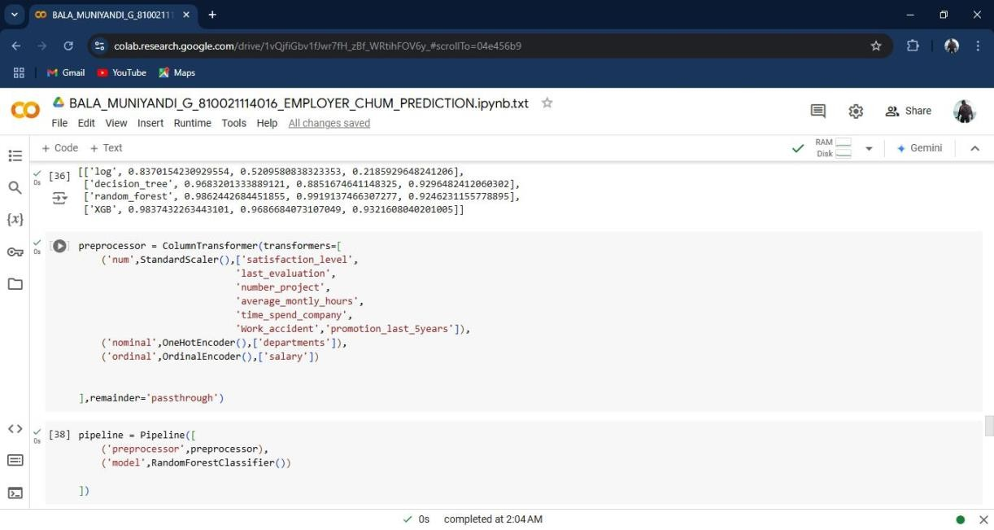

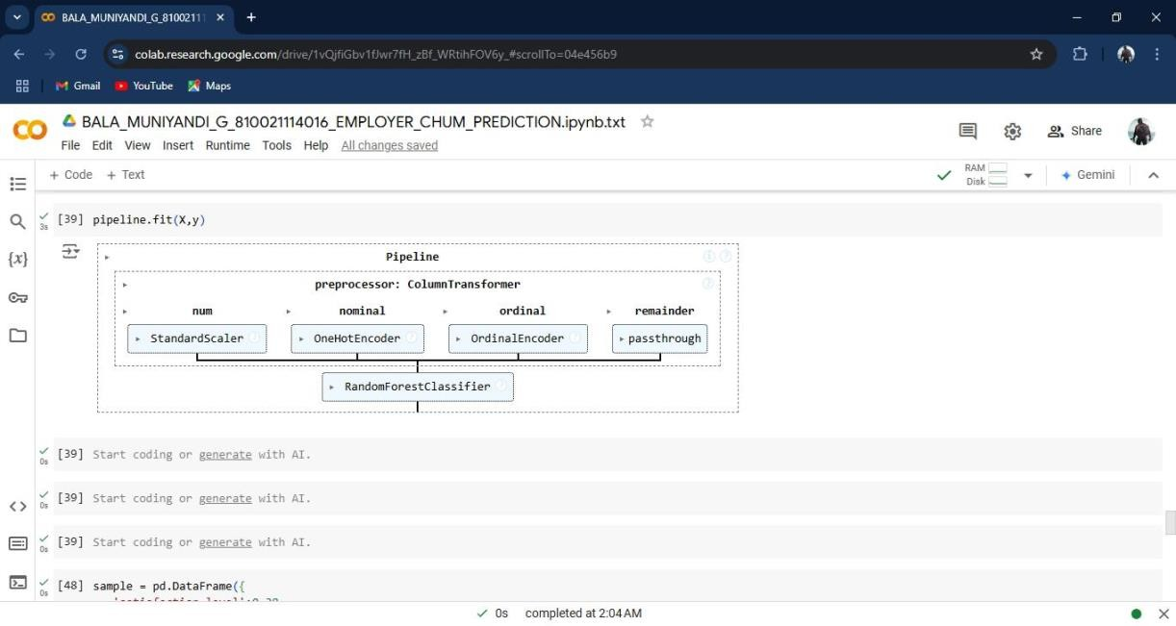

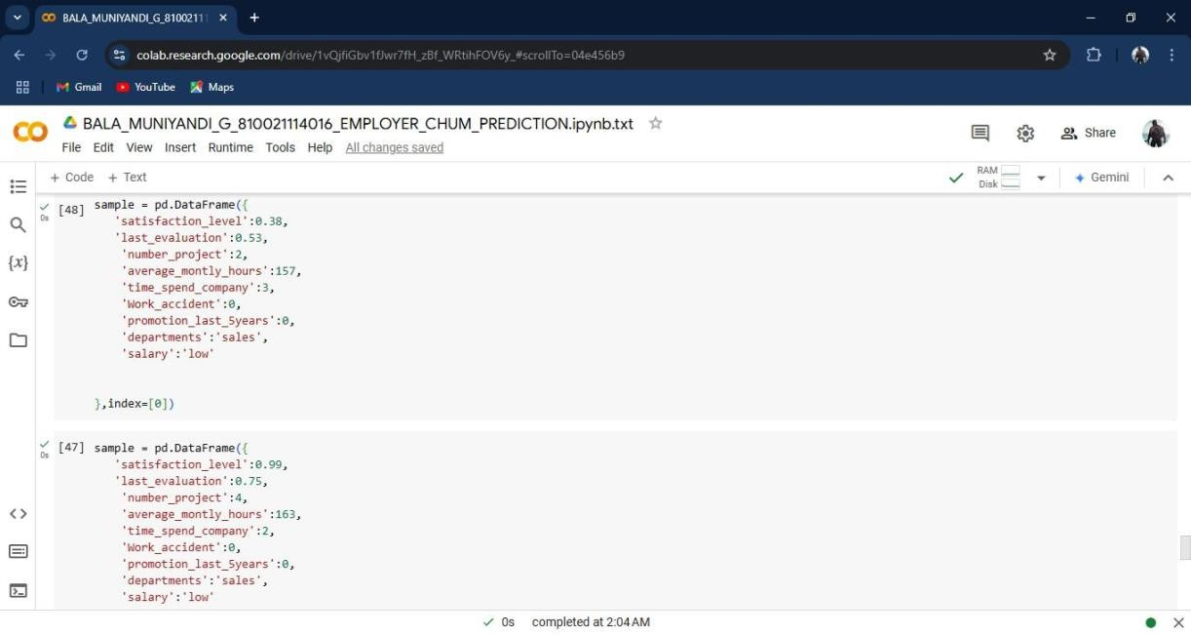

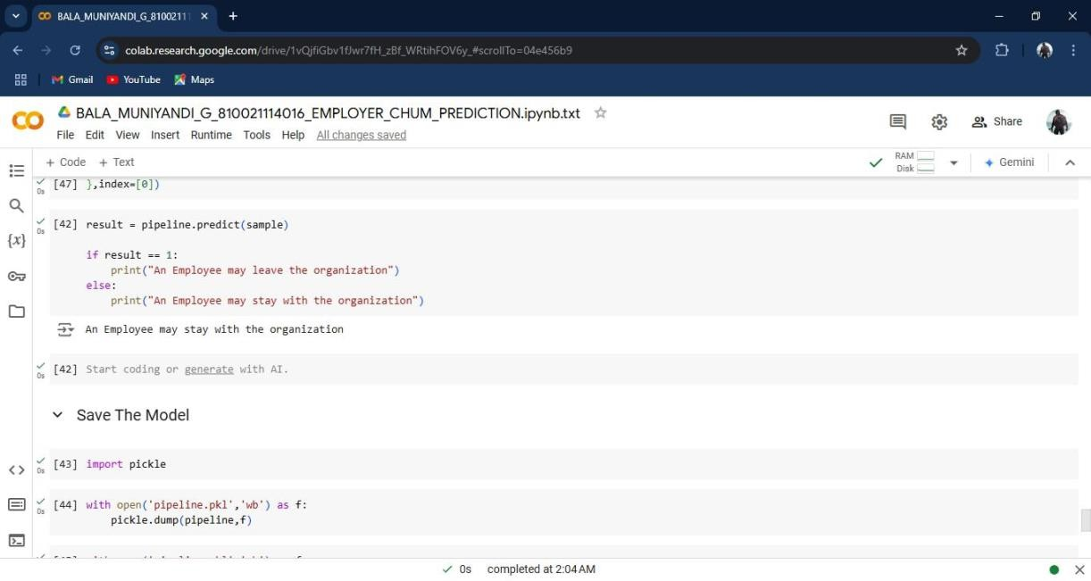

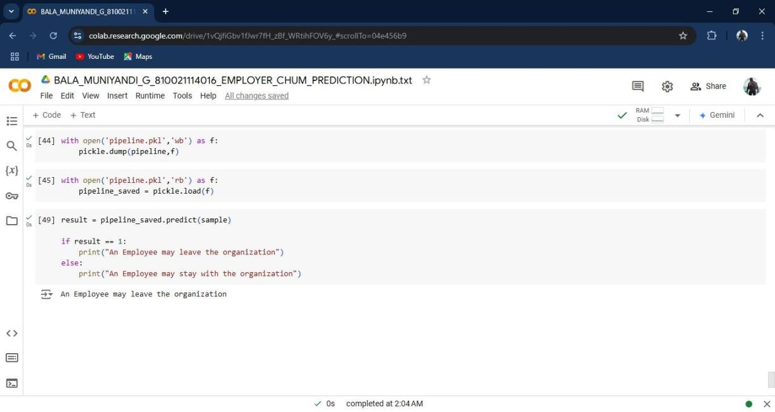

**CHAPTER 5**

**Feature importance and interpretation**

* 1. Feature Importance Analysis

The most significant features in predicting churn were:

* + 1. Monthly Income
    2. Job Satisfaction
    3. Years with Company
    4. Promotion in Last 5 Years
  1. SHAP Analysis

Using SHAP values, we interpreted the gradient boosting model. Results indicated that lower monthly income and job satisfaction significantly increased the likelihood of an employee leaving.

* 1. Key Insights

Employees with low monthly income are more likely to leave.

Lack of promotion over five years is also a significant churn factor.

Job satisfaction has a substantial impact on retention.

* 1. Recommendations

Based on the model’s findings, here are some recommendations:

1. **Enhance Job Satisfaction:** Initiatives to improve job satisfaction, such as recognizing achievements, may reduce churn.
2. **Competitive Compensation:** Offering competitive salaries could reduce the risk of employees leaving for better-paying jobs.
3. **Career Development Opportunities:** Implementing structured promotion paths and career development programs could help in retaining employees.
4. **Regular Engagement Surveys:** Conduct regular employee surveys to assess job satisfaction and address potential churn indicators early.

**CONCLUSION**

This project successfully developed an employee churn prediction model using machine learning techniques. The gradient boosting model provided high accuracy and identified key factors influencing churn. While effective, this project had some limitations, including data constraints and possible biases. Future research could involve more advanced techniques, larger datasets, or deep learning approaches for improved accuracy.

**FUTURE SCOPE**

The future scope for employee churn prediction is broad, with advancements in technology and data science continuing to offer new possibilities for enhancing predictive models and improving employee retention strategies. Here are some key areas for future development:

1. **Integration of Real-Time Data:** Future models could incorporate real-time data from various sources, such as employee engagement platforms, performance metrics, and feedback tools. This would allow organizations to make proactive, real-time decisions to retain employees.
2. **Use of Advanced Machine Learning Models:** While traditional models like logistic regression and decision trees are widely used, advanced techniques such as deep learning, neural networks, and ensemble models could offer higher predictive accuracy and uncover complex patterns in large datasets.
3. **Incorporation of Sentiment Analysis:** Natural Language Processing (NLP) can analyze employee reviews, exit interviews, and internal communications to gauge sentiment. This qualitative data can provide additional insights into potential reasons for churn and improve prediction accuracy.
4. **Personalized Retention Strategies:** Future predictive models could be used to develop individualized retention strategies for at-risk employees. By identifying specific reasons for churn at the individual level, organizations can tailor interventions to meet unique employee need.
5. **Ethics and Fairness in Prediction Models:** With the rise of AI ethics, future churn prediction models may incorporate fairness-aware algorithms to ensure that predictions are unbiased and do not disproportionately target or affect any particular group of employees.
6. **Predictive Analytics as Part of Workforce Planning:** Predictive churn models can evolve to become a core part of strategic workforce planning, helping organizations forecast talent needs, manage skill gaps, and improve succession planning.
7. **Integration with Employee Wellness Programs:** Churn prediction could be integrated with wellness and mental health programs to detect early signs of disengagement or burnout. Organizations could use these insights to design wellness programs aimed at improving job satisfaction and reducing churn.
8. **Automated Alerts and Recommendations:** Future models could be embedded in HR management systems to provide automated alerts when employees show signs of potential churn. The system could offer recommendations for managers, such as scheduling feedback sessions or offering professional development opportunities.
9. **Cross-Industry Benchmarking:** With more organizations adopting employee churn prediction, cross- industry benchmarking could become possible, allowing companies to compare their churn rates and risk factors against industry standards, providing insights into common causes and effective solutions.
10. **Longitudinal Studies and Predictive Validity:** As organizations gather more longitudinal data over time, they can validate and improve churn prediction models.

This long-term data can help refine models, making them more accurate and tailored to specific organizational contexts.

In conclusion, employee churn prediction has significant potential for growth, with new technologies and methodologies offering more sophisticated, ethical, and actionable insights to help organizations retain their valuable talent.

**APPENDICES**

**APPENDIX A: CODE SNIPPETS**

Provide key code snippets here (e.g., model training, evaluation).

**APPENDIX B: GLOSSARY**

A glossary of key terms used in the report**,**

1. HR – Human Resource
2. EDA - Exploratory Data Analysis
3. ROC – Receiver – Operating Characteristic Curve
4. AUC – Area under the curve
5. NLP – Natural Language Processing
6. AI – Artificial Intelligence
7. SHAP – Shapley Additive explanations

**REFERENCES**

1. Huang, Q., & Wang, J. (2019). "A Predictive Model for Employee Churn Based on Machine Learning."
2. Nguyen, T., & Nguyen, Q. (2020). "Predicting Employee Turnover Using Machine Learning: A Case Study."
3. Raschka, S., & Mirjalili , V. (2019). Python Machine Learning (3rd Edition).
4. Khera, N., & Divya, K. (2019). "Predicting Employee Attrition with Machine Learning."
5. Garg, A., & Patel, H. (2018). "Comparative Analysis of Machine Learning Techniques for Employee Turnover Prediction."
6. Kaur, H., & Kang, V. (2021). "Employee Attrition Prediction: A Review of Machine Learning Techniques."